Anthropogenic Contribution to Global Warming and its Effects on Multiple Sea Level and Temperature Models
Chase Asher. Critical Review Paper. Geo 387H
Abstract
Since the Intergovernmental Panel on Climate Change (IPCC) released its third annual report there has been a great deal of discussion in the scientific community as well as in the media as to how accurate it is and what the actual effects of global warming will be. While most of the scientific community accepts the findings of the IPCC for the most part, there is a minority that takes umbrage with what they claim is, among other things, poorly done science. In this review I will cover several papers that discuss the many possible futures in store for our planet. The papers primarily deal with temperature and sea level change and the many factors which come together to create these phenomenon, with a focus on anthropogenic forcing.
Outline
- Intro
- Sea Level Change
  - By Thermal Expansion
  - By Ice Melt
    - Glacier Recession (Removing these from the outline destroyed the
    - Ice Sheet melting paper’s formatting)
- Temperature Change
  - Constant Composition Model
  - Constant Emission Model
- Conclusion
- Sources

I. Intro
Climate change effects us all, and it has reached the point where it is undeniable that is it occurring, and practically undeniable that anthropogenic forcing has something to do with it. It affects us in everyday life on a multitude of levels. Climate models have made nations choose to accept, or in some cases, not accept the Kyoto protocol and similar resolutions. This affects the global economy at the level of billions of dollars every year. On other more far reaching yet more serious fronts, sea level change and temperature change threaten to change our way of life. With people’s livelihood and lives hanging on it, it is little wonder that climate change takes up such a large portion of the news, even if it is a far reaching subject. With this in mind it serves a person well to be educated about the different models used to predict climate change, the effects of climate change, and how what we do as a species can change these predictions for better or worse.
II. Sea Level Change
Thermal Expansion

Thermal expansion in water is a component of sea level rise, as water warms up a given mass will increase in volume due to thermodynamics. This effect is difficult to imagine because it is impossible to see on a small scale without lab equipment. However, with the entire mass of the ocean, even an increase of less than a degree Celsius in average temperature can mean an increase of several centimeters in global sea level. As far as climate change, this equates to an unavoidable increase in sea level. Even if we were to stabilize green house gasses in the atmosphere today, the sea level and temperature would still rise over the next century because of the inertia of the climate system and its slow response to change. Meehl puts forth two different models to predict future temperature rise and sea level change due to thermal expansion. The first, a Parallel Climate Model, is an older more established model that has been used for several climate change experiments. The second model is the Community Climate System Model version 3, it is newer and has generally higher resolution and better parameterizations of many components in the model. The Parallel Climate Model has an equilibrium climate sensitivity of 2.1˚ C and a transient climate response of 1.3˚ C. The Community Climate System Model has an equilibrium climate sensitivity of 2.7˚ C and a transient climate response of 1.5˚ C. This means that the Community Climate System Model is more sensitive to change than the Parallel Climate Model. When applied to the end of the twentieth century, the models return a warming of .6˚ C and .7˚ C respectively. The observed value for average warming in the twentieth century was .6˚ C, so even though it is less sensitive, in this case the Parallel Climate Model is a better choice. The models predicted 3 cm and 5 cm of sea level rise respectively. You can see in these predictions that the CCSM is more susceptible to forcing than the PCM. The actual value for the sea level rise was between 15 and 20 cm. Remember that the models do not include meltwater, so the sea level rise is entirely due to thermal expansion, thus the model with the larger warming will always have the larger sea level rise. A side effect of this is that the predicted values for sea level rise are practically the absolute, even unrealistic, minimum to be expected.
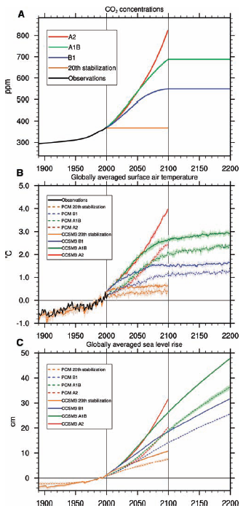
In future predictions, both models see temperature increase and sea level rise no matter what. In the impossible case that greenhouse gasses stopped entering the atmosphere in 2000, the entire globe would still be warmed by .4˚ C for the PCM and .6˚ C for the CCSM. Sea level rise will be even higher because of continued thermal expansion. The charts below display several different CO2 concentrations in the atmosphere and how they would affect the climate in the realm of increasing temperature and rising sea level due to thermal expansion. The CO2 levels shown in graph A come from the Special Report for Emissions Scenarios. I will call them low medium and high, corresponding to B1, A1B, and A2. Note that the twentieth century stabilization is far below any of them. According to Meehl, even the medium level would be difficult to reach without reducing emissions below what they were in the nineties. That would be a gargantuan task in itself, so for now the most likely scenario, assuming now change, is the high CO2 emissions. In the charts you can see several features already discussed, the higher sensitivity of the CCSM as compared to the PCM is displayed in figure B. Also, the first two figures show how accurately the models correspond with the observed data for the twentieth century.
The next set of figures show global surface temperature models as predicted by the PCM and CCSM. In them you can see quantitatively the differences between the models, and also the differences between the various CO2 models.
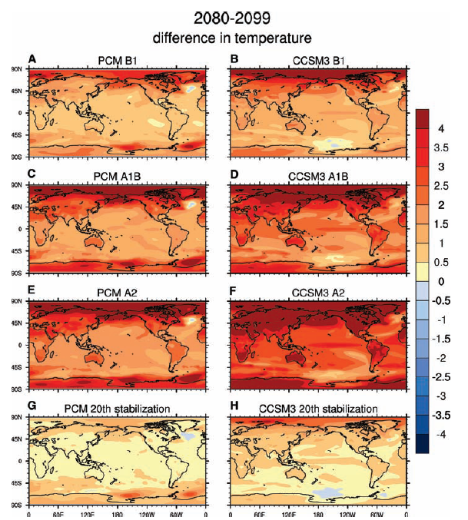

In these graphs you will notice the larger temperature increase in the CCSM model, once again due to the increased sensitivity. Of note is the global increase of temperature at the poles, but especially in the north Atlantic. This phenomenon is due to a decrease in the meridional overturning in the Atlantic, which causes a greater forced response and more warming commitment due to the more defined thermocline. Overall, thermal expansion will contribute to sea level rise in the next century to some degree, but the extent of the damage done is determined by our emissions.

Ice Melting

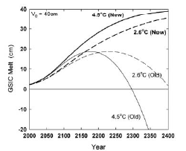
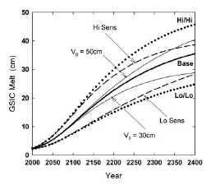
The IPCC dedicated an entire chapter to sea level rise in the next hundred years in their Third Assessment Report. However, according to Wigley, the scenario and formula laid out in this chapter can not be used past 2100 because of an empirical limitation. It imposes a hard cap on the amount of melted ice, and so it can not reasonably account for melting after the year 2100, it will always underestimate it once it goes over a certain level. The TAR formula for ice melt deals only with glaciers and small ice caps, the larger ice sheets on Antarctica and the margins of Greenland are not taken into account because they are growing. This growth occurs despite globally increasing temperatures because of local conditions advantageous for ice growth, most notably increased snowfall over the west Antarctic shelf. Wigley and Raper extended the TAR formula to apply to times after 2100. To do so they changed the mass balance sensitivity and several other constants to create a new formula which satisfied the following requirements: “It is identical to the TAR formula for short times; it does not suffer from the artificial melt maximum arising from the quadratic area correction factor; the melt tends asymptotically to the initially-available ice volume; and the new area correction method is based on a physical, albeit very simple, model.” This new formula makes one important assumption, that the global mass balance sensitivity is dependent on the area of glaciers and small ice caps in a linear manner. In the first figure, you can see how the two formulas compare for two different levels of warming. It is easy to see the failure of the first TAR model, after 2100, GSIC melt falls off abruptly, especially at the higher temperatures associated with greater CO2 concentration. The new TAR model not only matches the old model up to the year 2100, it also avoids the problem of reaching the maximum melt level. So it is the better model for the time after 2100.
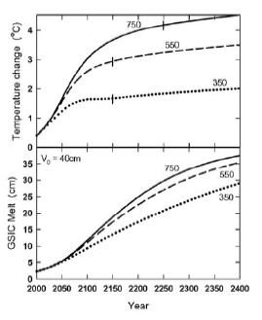
The next figure is a set of stabilizations for CO2, showing possible sea level rise due to glacial melting if the CO2 stays at that level (550 ppm). As was the case in the first section, even after CO2 concentration stabilizes, the radiative forcing continues to increase due to climate inertia. It also shows the difference between various mass balance sensitivities and initial ice volumes.
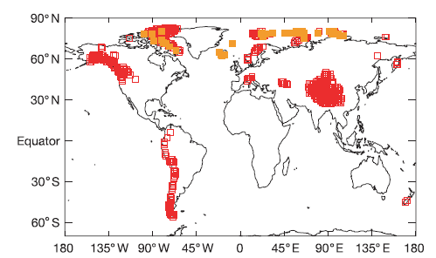
The final diagram above illustrates the changes that can be expected with various levels of stabilized CO2, at 350, 550, and 750 ppm. As is to be expected, larger concentrations of greenhouse gasses lead to more sea level rise and temperature change. Another attribute is the longer amount of time it takes to stabilize larger amounts of CO2 in the atmosphere. So overall we can expect continuing sea level change as a result of melting ice.
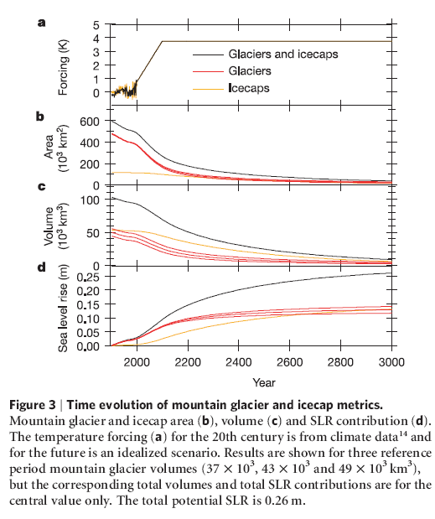
In another paper, Raper predicts that the increase will be between .046 and .051 due to melting of Glaciers and small ice caps (Raper,2006) . This prediction is half what was previously predicted. It specifically models melting combined with geometric ice volume, excluding Greenland and Antarctica for the reasons mentioned earlier. It found that mountain glaciers are melting faster than ice caps and applied separate treatment for volume loss to reach this lower bound of glacial ice’s contribution to global sea level rise. The difference in contribution between mountain glaciers and ice caps is appreciable because the alpine glaciers are more susceptible to climate change. For three different assumed glacier volumes in the survey, glaciers always contributed more than ice caps to sea level rise for several hundred years. In the smallest volume model, ice caps did not catch up until approximately 2600, in the medium one it did not catch up until approximately 2825, and in the model which had the largest alpine glacier volume (49000 cubic kilometers) the ice cap contribution had not equaled the glacier contribution even by the year 3000. These observations are clearly visible in the chart labeled figure 3. You will notice that the contributions begin to curve more evenly after the initial drop of glacial ice area to ice cap levels, showing just how effective the volumetric model is at sorting the sources out. The reason for this discrepancy between the alpine glaciers and ice caps is simple physics. The alpine glaciers cover far greater area than the ice caps do, but they also have equal or less volume depending on what model you follow. Therefore they are simply exposed to more watts per square meter, causing faster melting until enough has disappeared that they have similar physical properties to the ice caps.
Figure showing the location of icecaps (orange) and glaciers (red)

Glacial ice and the planet’s ice caps contribute an appreciable amount to the slowly rising sea level. Different papers give opposing views about whether it contributes more or less than thermal expansion, but there is growing consensus that the primary factor in whether a glacier grows or recedes is temperature, rather than precipitation (Raper, 2006). If this proves true then it can be expected that glacial ice will continue to melt, independent of CO2 levels or precipitation.

III. Temperature Change
Long term climate change is an unavoidable truth. Anthropogenic climate forcing on the other hand, is a more avoidable reality. In this section I will discuss a few climate models for how much warming we have already committed ourselves to, and projected future warming based on human greenhouse gas emissions. I will also go into some detail about sea level change again, as it is included in these models.

Constant Composition Model
The constant composition model is impossible to achieve. It is the model of potential warming if the greenhouse gasses in the atmosphere that were present in the atmosphere in 2000 remained constant in concentration, this means that there are no greenhouse gas emissions past 2000. This obviously can not be achieved, but it serves as a good base line estimation of potential warming that we would face over the next several centuries, and a good model of how the climate would behave if we suddenly stopped emitting greenhouse gasses. The premise behind it is to show not only the baseline estimation, but to prove that climate change lags behind actual forcing factors because of oceanic thermal inertia. Mathematically, the warming commitment is the difference between equilibrium warming for forcing at any time and the realized warming up to that point in time. Following this, the current equilibrium warming commitment is about .5˚ C, with a large uncertainty. The problem with this solution is that it will take an infinite amount of time for the warming commitment to be felt. Wigley solves this by making unrealized warming a time dependent quantity. The same gas-cycle/climate model that was used in the IPCC third assessment report is used to create the models for unrealized warming, for sea level rise Wigley uses the corrected TAR formula from Meehl in order to project beyond the year 2100. The chart below shows the results of the model for varying aerosol forcing levels and climate sensitivities. 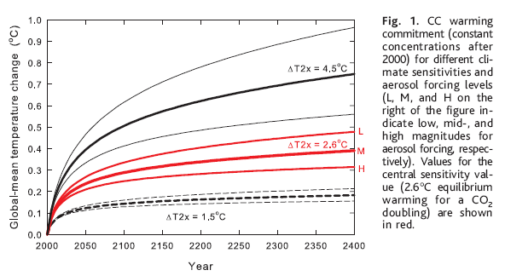
You can see that the primary factor in how much warming will occur is the climate sensitivity, with aerosol forcing magnitude basically pulling the result up or down depending on severity. At higher climate sensitivities, aerosol forcing gains importance, making the difference between a .5˚ C temperature increase and a 1˚ C temperature increase.
The constant composition model has a large uncertainty to its sea level prediction due to uncertainty in the ice melt, unforced contributions, and the rate of ocean heat uptake. It was found that unforced effects are a appreciable component of sea level rise, if not the chief component. The chart below displays, in a similar manner as the temperature, the sea level rise predicted for varying climate sensitivities and aerosol forcing levels. The behavior 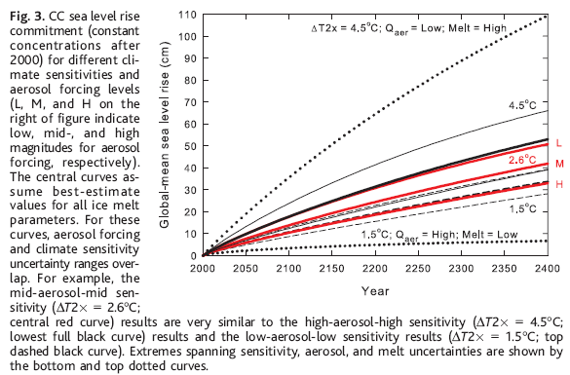
follows the same basic pattern as the temperature graph, with aerosol forcing contributing more at higher climate sensitivities. With optimal conditions only a small sea level rise will be realized in the CC model, less than 2.5 cm per century. However, the worst conditions would equate to a sea level rise of close to 30 cm per century, with about one quarter of that coming from unforced effects.
The CC model has highly varying outcomes due to the apparent effects of both climate sensitivity and past aerosol forcing. The model guarantees a warming of at least 1˚ C from inertia alone and a probable sea level rise of about 10 cm per century. This is an extreme lower limit, with no new CO2 added after 2000.

Constant Emission Model
The constant emission model is more realistic than the CC model, it fixes emissions rates at the 2000 level and makes climate models based on that. While it is a theoretically plausible model, it too is still probably lower than the actual potential rise in temperature because greenhouse gas emissions are still increasing.
The shows a different story for future temperature:
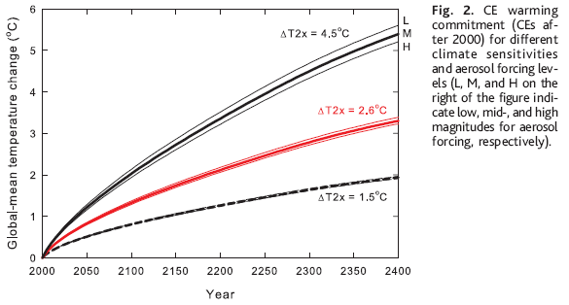
The increase in temperature is much more dramatic with the increasing equilibrium temperature as compared to the constant composition model. Aerosol forcing is also very much damped in comparison with the constant composition model. The primary factor affecting future temperature in this model is climate sensitivity, with even the extreme low equating to an increase in temperature by 1˚ C in the next century alone. The higher end of the scale is approximately double that, and worse as time continues. There is no potential ceiling for increasing temperature for this model like there is in the constant composition model, so the increase will be more linear in this situation.
Sea level increases are intimately tied to temperature increases, so it comes as no surprise that the sea level graph for the constant emission situation follows a similar trend:
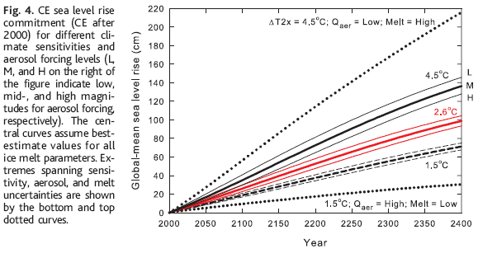
The trends here are similar to those in the temperature graph; once again the contribution from aerosol forcing has been marginalized in favor of increased reaction to climate sensitivity. The graph does not look as dramatically different from the CC model as the temperature graph does because there is a limited volume of ice as discussed in the revised melt equation from the TAR from IPCC. The main difference as that, in general, you can expect twice as much melting from the CE model as the CC model.
Ultimately what we see from these experiments is that temperature change and sea level rise is a commitment which has been unavoidably committed to since the ocean’s thermal inertia is still catching up to the current equilibrium temperature. The measurement of future temperature and sea level rise is still to be seen, but estimates would be safe at approximately 1˚ C per century and 10 cm per century for several more centuries. These results compel us to change emissions practices drastically if we want to curtail these changes.

IV. Conclusion
By examining the various models and predictions put forth in the papers reviewed here, only one conclusion is carried through all of them: global warming and sea level rise is unavoidable. The papers all differ in their predictions of severity for glacial melting, temperature change, thermal expansion and many other quantities, and most disagree with the IPCC TAR on various issues. Long term climate prediction is a difficult science but a worthwhile one, by creating these models we can see potential futures and try to alter them. The reasons for wanting to do so are many in number, ranging from protecting delicate habitats to protecting beach houses. The real world application of this science can not be denied.

Literature Sources:
1. Meehl , Gerald A et al. (2004)How Much More Global Warming and Sea Level Rise? Science, Vol 307, page 1769-1772.
2. Wigley, T.M.L.. (2004) The Climate Change Commitment. Science, Vol 307, page 1766-1769.
3. Kohfeld, Karen E. et al. (2004) Role of Marine Biology in Glacial-Interglacial CO2 Cycles. Science, Vol 308, page 74-78.
4. Wigley, T. M. L. and Raper, S. C. B. (2004) Extended scenarios for glacier melt due to anthropogenic forcing. Geophysical Research Letters, Vol 32, L05704, doi:10.1029/2004GL021238, 2005.
5. Hansen, James (2005) A slippery slope: How much global warming constitutes “Dangerous anthropogenic interference”? Climactic Change, Vol 68, 269-279.
6. Koch, Dorothy and Hansen, James Distant origins of Arctic black carbon: A Goddard
Institute for Space Studies ModelE experiment. JOURNAL OF GEOPHYSICAL RESEARCH, VOL. 110, D04204, doi:10.1029/2004JD005296, 2005
7. Raper, S.C.B. and Braithwaite, Roger J. Low sea level rise projections from mountain
glaciers and icecaps under global warming. Letters, Vol 439, 19 January 2006, doi:10.1038/nature04448

